**CALCULATING FAMILY EXPENSES**

|  |  |
| --- | --- |
| Team id | LTVIP2025TMID29041 |
| Project Name | Calculating Family Expenses |
| College Name | Kandula Lakshumma Memorial College of Engineering for Women |
| course | Computer Science Engineering |

**Step1:setting up serviceNow Instance**

* + - Go to the ServiceNow Developer Site. (<https://developer.servicenow.com/>)
* Sign In to the Developer Account.

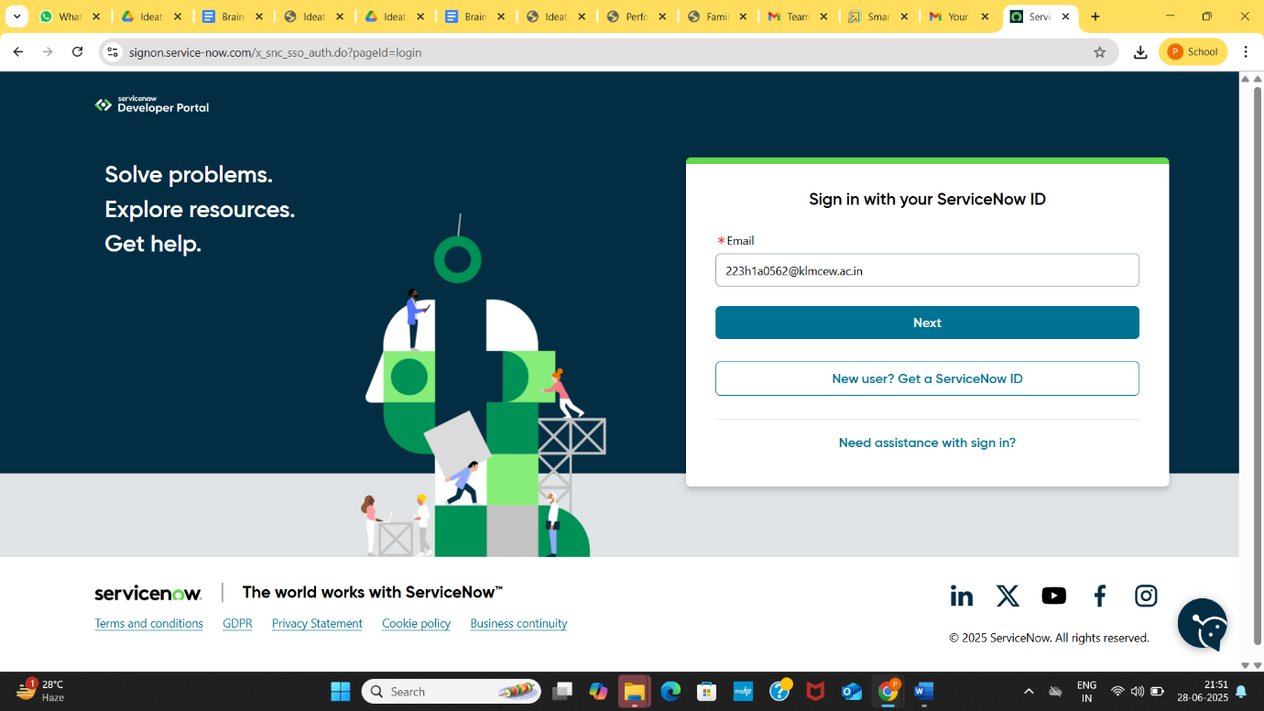

**• Request a Personal Developer Instance (PDI)**

➢ Click on the profile icon at the top-right corner.

➢ Select “Manage Instance” or go directly to the link.

➢ Click “Request Instance”.

➢ Choose the latest version (default selection is recommended).

* **Access your Instance**

➢ You’ll get an instance URL (<https://dev225052.service-now.com>)

➢ Click “Open Instance” to launch it.

➢ Your admin credentials (username & password) will be shown-copy and save them securely

➢ Log in to Your Instance.

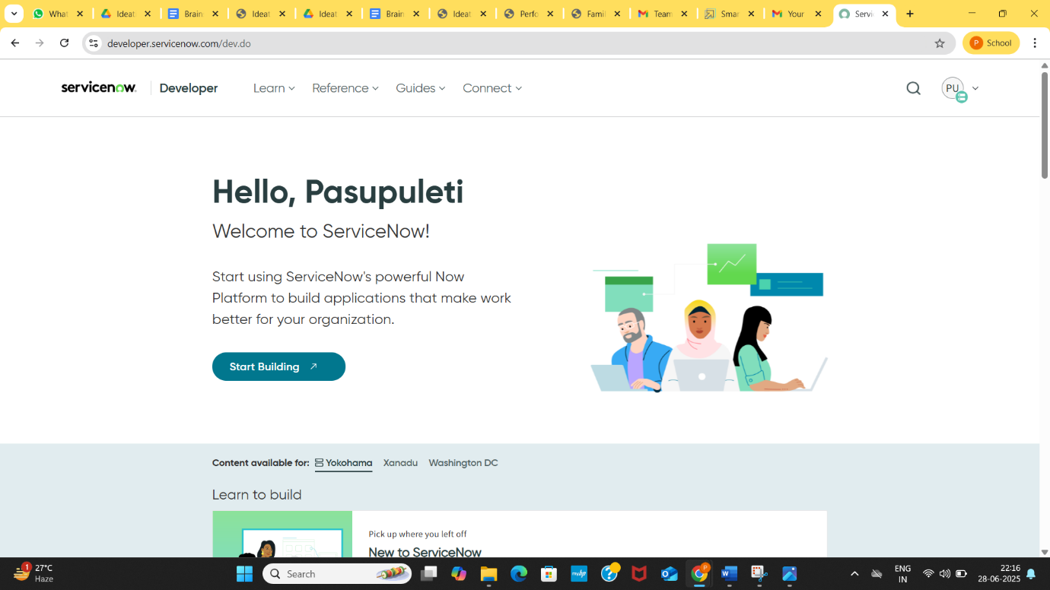

**Usage:**

• Use the Application Navigator (left sidebar) to explore modules like:

➢ Incident, Problem, Change Management.

➢ Service CatLog. Usage

➢ Configuration Management (CMDB).

• Use App Engine Studio or ServiceNow Studio to build or customi